**Instructions to run**

1. **R installation and setup**
2. **Tomcat installation and the services setup**

**c) Node.js installation and ‘ATM Recommender’ service setup**

**d) Nox installation and Mobile application setup**

**a) R installation and setup**

1. Download R executable from <http://cran.us.r-project.org/>.
2. Install R. Leave all default settings in the installation options.
3. Installing the Packages (libraries) required.

Click on the R executable -> create a new .R script

(File -> New File -> R Script) and run the below commands.

install.packages (dplyr)

install.packages (queueing)

install.packages (plyr)

install.packages (lubridate)

1. Unzip the *BoB_hackathon_workspace.zip* into a directory of preference.
2. Update the R scripts with the unzipped directory location appropriately for the below scripts

*BOB_DT_Training.R*

*BOB_DT_Predict.R*

*BOB_Lambda_Predicition_Training.R*

*BOB_Lamda_Prediction_Input.R*

*BOB_Waiting_Time_Predicition.R*

Example: setwd ("C:\\Work\\BIG_DATA\\BankOfBaroda\\BoB_hackathon_workspace\\R_DT_Recommend")

setwd ("<Path to the unzipped location>\\BoB_hackathon_workspace\\R_DT_Recommend")

1. Relative folder Structure on top of the unzipped directory location

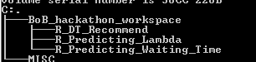

1. Click on the R runtime icon and open the .R script ( File -> Open Script-> Navigate to the location of R file )
2. Select All and Hit Enter to execute. To see the working of the Individual Script

R_Predicting_Lambda folder contains the code for predicting arrival rate

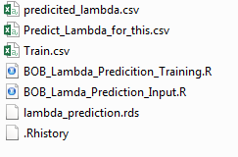

BOB_Lambda_Predicition_Training.R contains the code that take Train.csv as input and creates model lambda_prediction.rds

*BOB_Lambda_Predicition_Input.R* contains the code that refers the model created by the *BOB_Lambda_Predicition_Training.R script* and predicts the number of customers arrivals for the list of the ATMs specified in *Predict_Lambda_for_this.csv*

*R_Predicting_Waiting_Time* folder contains the code for predicting waiting time.

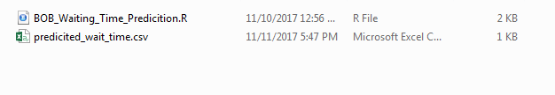

*BOB_Waiting_Time_Predicition.R* contains the code that predicts the waiting time from the ATMs in the Predict_Lambda_for_this.csv

R_DT_Recommend folder contains code that recommends the ATMs

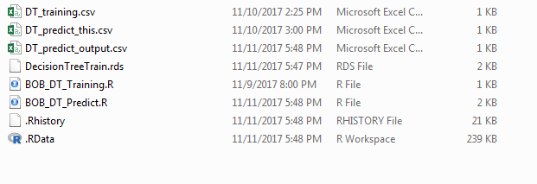

*BOB_DT_Training.R* contains the code that create the Model for recommending the ATM. *DT_Training.csv* is used to train and create this model.

*BOB_DT_Predict.R* contains the code that recommends ATMs from the list of the ATMs in the *DT_Predict this.csv*

*NOTE: change the path “C:\\Work\\BIG_DATA\\BankOfBaroda” in all the R script with the unzipped location*

**b) Tomcat installation and the services setup**

**Tomcat Installation**

* **Download and install apache tomcat 9.0 (https://tomcat.apache.org/download-90.cgi)**
* **Checkout the code from Github to local Workspace in eclipse**
* **Change the IP_ADDRESS to the system IP where the code is extracted**

**Application : WaitTimePrediction, class : BOBAtmApiServiceforR**

* **Generate below war(s) from local workspace using maven**

**AtmCashNoCash**

**BankApiCall**

**AtmUpDown**

**GoogleApi**

**Recommender**

**WaitTimePrediction**

* **Deploy war file in tomcat server**
* **Start the tomcat.**

**c) Node.js installation and ‘ATM Recommender’ service setup**

* Install node.js version 6+ onwards from the website <https://nodejs.org/en>
* Copy “ATMRecommendor.zip” in any drive.
* Open command prompt and go to the “ATMRecommendor” directory
* Change the IP_ADDRESS in routes.js file
* Run command “node index.js”

*C:\ ~ * ATMRecommendor *>node index.js*

* Once you run node.js application, it will give a message (“App listening on port 8082”) on command prompt.
* This verifies that the Node.js installation setup is working and Node.js setup for ATM Recommender service setup is successful.

**d) Mobile application setup and Nox installation**

* **Checkout code from Github to local workspace in Android studio**
* **Install Nox player in windows and use it as emulator**
* **Change NodeJS IP_ADDRESS in MainActivity class in the M-Connect Plus Application**
* **run Android application download and install Nox app player from (**[**http://filehippo.com/download_nox-app-player/**](http://filehippo.com/download_nox-app-player/)**)**
* **goto Nox installed folder in MS-DOS and execute bellow command**

**nox_adb.exe connect <IP_ADDRESS>:<port>**